**Isle of Wight**

The Isle of Wight Festival is a British [music festival](https://en.wikipedia.org/wiki/Music_festival) which takes place annually in [Newport](https://en.wikipedia.org/wiki/Newport,_Isle_of_Wight) on the [Isle of Wight](https://en.wikipedia.org/wiki/Isle_of_Wight), [England](https://en.wikipedia.org/wiki/England).[[1]](https://en.wikipedia.org/wiki/Isle_of_Wight_Festival#cite_note-Visit_Britain_IOW_Festival-1) It was originally a [counterculture](https://en.wikipedia.org/wiki/Counterculture_of_the_1960s) event held from 1968 to 1970.

The [1970 event](https://en.wikipedia.org/wiki/Isle_of_Wight_Festival_1970) was by far the largest of these early festivals and the unexpectedly high attendance levels led, in 1971, to [Parliament](https://en.wikipedia.org/wiki/Parliament_of_the_United_Kingdom) adding a section to the Isle of Wight County Council Act 1971 preventing overnight open-air gatherings of more than 5,000 people on the island without a special licence from the council. The event was revived in 2002.

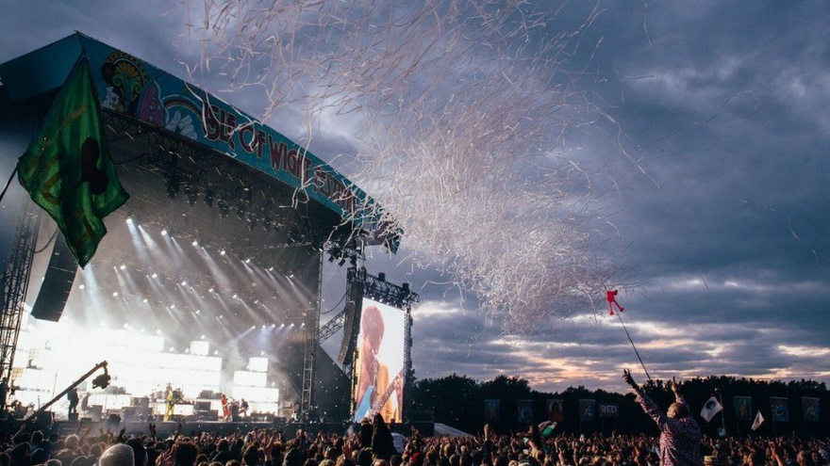

**Original festival**

The original events were promoted and organised by the Foulk brothers (Ron and [Ray Foulk](https://en.wikipedia.org/wiki/Ray_Foulk)) under the banner of their company Fiery Creations Limited and their younger brother Bill Foulk. The venues were Ford Farm (near [Godshill](https://en.wikipedia.org/wiki/Godshill" \o "Godshill)), [Wootton](https://en.wikipedia.org/wiki/Wootton,_Isle_of_Wight) and [Afton Down](https://en.wikipedia.org/wiki/Afton_Down) (near [Freshwater](https://en.wikipedia.org/wiki/Freshwater,_Isle_of_Wight)) respectively.[[5]](https://en.wikipedia.org/wiki/Isle_of_Wight_Festival#cite_note-BBC_IOW_Festival_history-5) The 1969 event featured [Bob Dylan](https://en.wikipedia.org/wiki/Bob_Dylan) and the Band. This was Dylan's first paid performance since his motor cycle accident some three years earlier, and was held at a time when many still wondered if he would ever perform again. Followers from across the world trekked to the Isle of Wight for the performance. Estimates of 150,000–250,000 attended. The 1969 festival opened on Friday 29 August—eleven days after the close of [Woodstock](https://en.wikipedia.org/wiki/Woodstock_Festival). Dylan was living in Woodstock, New York, at the time and it was widely believed that he would perform there, after the event had been "put in his own backyard". As it happened, Dylan left for the Isle of Wight on 15 August—the day the Woodstock festival began.

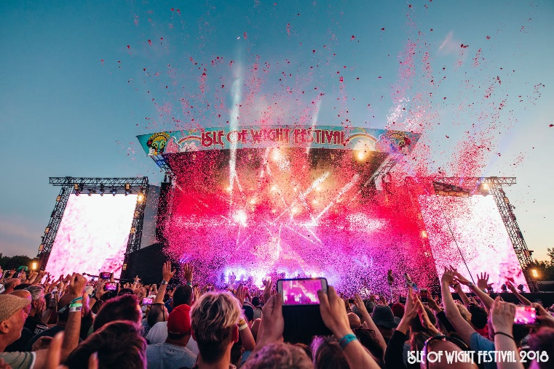

The [1970 event](https://en.wikipedia.org/wiki/Isle_of_Wight_Festival_1970) was by far the largest of these early festivals; indeed it was said at the time to be one of the largest human gatherings in the world, with estimates of over 600,000, surpassing the attendance at [Woodstock](https://en.wikipedia.org/wiki/Woodstock_Festival). Included in the line-up of over fifty performers were [Jimi Hendrix](https://en.wikipedia.org/wiki/Jimi_Hendrix), [Miles Davis](https://en.wikipedia.org/wiki/Miles_Davis), [The Doors](https://en.wikipedia.org/wiki/The_Doors), [The Who](https://en.wikipedia.org/wiki/The_Who), [Lighthouse](https://en.wikipedia.org/wiki/Lighthouse_(band)), [Ten Years After](https://en.wikipedia.org/wiki/Ten_Years_After), [Terry Reid](https://en.wikipedia.org/wiki/Terry_Reid), [Emerson, Lake & Palmer](https://en.wikipedia.org/wiki/Emerson,_Lake_%26_Palmer), [Joni Mitchell](https://en.wikipedia.org/wiki/Joni_Mitchell), [The Moody Blues](https://en.wikipedia.org/wiki/The_Moody_Blues), [Melanie](https://en.wikipedia.org/wiki/Melanie_Safka), [Donovan](https://en.wikipedia.org/wiki/Donovan), [Gilberto Gil](https://en.wikipedia.org/wiki/Gilberto_Gil), [Free](https://en.wikipedia.org/wiki/Free_(band)), [Chicago](https://en.wikipedia.org/wiki/Chicago_(band)), [Richie Havens](https://en.wikipedia.org/wiki/Richie_Havens), [John Sebastian](https://en.wikipedia.org/wiki/John_Sebastian), [Leonard Cohen](https://en.wikipedia.org/wiki/Leonard_Cohen), [Jethro Tull](https://en.wikipedia.org/wiki/Jethro_Tull_(band)), [Taste (Irish band)](https://en.wikipedia.org/wiki/Taste_(Irish_band)) and [Tiny Tim](https://en.wikipedia.org/wiki/Tiny_Tim_(musician)). The unexpectedly high attendance levels led, in 1971, to [Parliament](https://en.wikipedia.org/wiki/Parliament_of_the_United_Kingdom) adding a section to the Isle of Wight County Council Act 1971 preventing overnight open-air gatherings of more than 5,000 people on the island without a special licence from the council.[[6]](https://en.wikipedia.org/wiki/Isle_of_Wight_Festival#cite_note-6)

The 1970 festival was filmed by a film crew under director [Murray Lerner](https://en.wikipedia.org/wiki/Murray_Lerner), who at that point had just directed the Academy Award-nominated documentary Festival of the Newport Folk Festival. The footage passed to Lerner in settlement of legal fees after a dispute with the Foulk brothers in which each side claimed against the other for breach of contract. Lerner distilled material from the festival into the film Message to Love (released on video in the US as Message to Love: The Isle of Wight Festival: The Movie[[7]](https://en.wikipedia.org/wiki/Isle_of_Wight_Festival#cite_note-7)) released theatrically in 1996 and subsequently on DVD. In addition to this film, Lerner has created full-length films focused on performances by individual artists at the 1970 festival. To date there have been individual films of [Miles Davis](https://en.wikipedia.org/wiki/Miles_Davis), [Jimi Hendrix](https://en.wikipedia.org/wiki/Jimi_Hendrix), [The Who](https://en.wikipedia.org/wiki/The_Who), [Emerson, Lake & Palmer](https://en.wikipedia.org/wiki/Emerson,_Lake_%26_Palmer), [The Moody Blues](https://en.wikipedia.org/wiki/The_Moody_Blues), [Free](https://en.wikipedia.org/wiki/Free_(band)), [Taste (Irish band)](https://en.wikipedia.org/wiki/Taste_(Irish_band)), [Leonard Cohen](https://en.wikipedia.org/wiki/Leonard_Cohen), [Jethro Tull](https://en.wikipedia.org/wiki/Jethro_Tull_(band)), [The Doors](https://en.wikipedia.org/wiki/The_Doors) and [Joni Mitchell](https://en.wikipedia.org/wiki/Joni_Mitchell). Dave Roe (ex Liverpool Collegiate) produced all the psychedelic artwork for posters and advertising material.